**Department of Computer Science and Engineering**

**19CSE101 – Computer Systems Essentials**

**ONLINE NEWS PAPER**

**Batch:** 2021-2025

**Semester:** 1​

**February 2022**

|  |  |  |
| --- | --- | --- |
| **Sl. No** | **Roll No.** | **Name** |
| **1** | **CB.EN.U4CSE21062** | **T. Harsha Vardhan** |
| **2** | **CB.EN.U4CSE 21063** | **T.Vinay Kumar** |
| **3** | **CB.EN.U4CSE 21064** | **U.Siddarth Varma** |
| **4** | **CB.EN.U4CSE 21065** | **Vaishnavi.S** |

**TABLE OF CONTENTS**

|  |  |
| --- | --- |
| **S.NO** | **TOPIC** |
| 1. | INTRODUCTION |
| 2. | TYPE OF APPLICATION |
| 3. | OPERATING SYSTEM FOR THE APPLICATION |
| 4. | DATABASE DESIGN AND QUERIES FOR THE APPLICATION |
| 5. | NETWORKING MODEL FOR THE APPLICATION |
| 6. | SUMMARY |
| 7. | REFERENCES |

**INTRODUCTION**

**WHAT IS ONLINE NEWS PAPER?**

* Online news paper is the version of a newspaper, either as an online stand-alone publication or as the online version of a printed periodical.
* An online newspaper can be read more elaborate than a printed newspaper.
* You can read the old issues too very easily at the click of the mouse. On the other hand, you have to get prior permission from the librarian to go through the old issues of a printed newspaper.

 

**TYPE OF APPLICATION**

**MOBILE APPLICATION**

We take android into consideration to build this application

**Uses**

* The mobile app of online newspaper is user-friendly.
* At present where people mostly use their mobile phones and need all information right on their handsets, it is necessary to have a mobile app for every magazine or newspaper business.

**WEB APPLICATION**

We take windows into consideration to build this application

**Uses**

* Web application of online newspaper gives you a big page which acts like a printed newspaper free of cost.
* We can go back to old newspapers easily in web app but in the case of printed newspapers we need to get the permission of librarian.
* The application can be used in laptop, pc and in smart phones to at free of cost.

**Users of the application (for both web and mobile)**

* This application is available for everyone in the world irrespective of their version/Type of devices they use.
* People who prepare for competitive exams which involves current affairs and needs to check previous papers will finds this web application useful.

**Type of client devices**

This application can be used by clients in smartphones, desktops and laptops.

**OPERATING SYSTEM FOR THE APPLICATION**

**1.Mobile application – Android is the OS**

**Why android as OS?**

Android is a platform that is easier to master for developers having varying skill levels. Mobile app development services can utilize Android with much greater ease than any other platform. Android uses Java which is a programming language that most developers are intimately familiar with.

Android has a huge number of clients from increasingly diverse backgrounds, applications are less expensive. Most of the applications are free to download and are also easily available on the play store in comparison to another operating system.

**Number of users in the world**

Android is the most popular operating system in the world, with over 2.5 billion active users spanning over 190 countries.

**Who developed android:**

Android is developed by a consortium of developers known as the Open Handset Alliance and commercially sponsored by Google.

[**Author**](https://www.google.com/search?rlz=1C1CHBF_enIN975IN975&q=android+original+author&stick=H4sIAAAAAAAAAOPgE-LSz9U3MCqvKEkv11LNTrbST87PLSgtSS3SL85PKylPLEq1yi_KTM_MS8yJTywtycgvWsQqnpiXUpSfmaIAk1GAyAAATKTJ0k8AAAA&sa=X&ved=2ahUKEwj-h8zJuZP1AhX-xzgGHWJEBxwQ6BMoAHoECBMQAg)**:**[Google](https://www.google.com/search?rlz=1C1CHBF_enIN975IN975&q=Google&stick=H4sIAAAAAAAAAOPgE-LSz9U3MCqvKEkvV-IEsU1Mk82TtFSzk630k_NzC0pLUov0i_PTSsoTi1Kt8osy0zPzEnPiE0tLMvKLFrGyuefnp-ek7mBlBABlkW6QTAAAAA&sa=X&ved=2ahUKEwj-h8zJuZP1AhX-xzgGHWJEBxwQmxMoAXoECBMQAw), [Huawei](https://www.google.com/search?rlz=1C1CHBF_enIN975IN975&q=Huawei&stick=H4sIAAAAAAAAAOPgE-LSz9U3MCqvKEkvV-IEsQ0Ls3MMtVSzk630k_NzC0pLUov0i_PTSsoTi1Kt8osy0zPzEnPiE0tLMvKLFrGyeZQmlqdm7mBlBAB2e9qjTAAAAA&sa=X&ved=2ahUKEwj-h8zJuZP1AhX-xzgGHWJEBxwQmxMoAnoECBMQBA), [Baidu](https://www.google.com/search?rlz=1C1CHBF_enIN975IN975&q=Baidu&stick=H4sIAAAAAAAAAOPgE-LSz9U3MCqvKEkvV-IEsU1zsy3itVSzk630k_NzC0pLUov0i_PTSsoTi1Kt8osy0zPzEnPiE0tLMvKLFrGyOiVmppTuYGUEAEzW2T9LAAAA&sa=X&ved=2ahUKEwj-h8zJuZP1AhX-xzgGHWJEBxwQmxMoA3oECBMQBQ), [Andy Rubin](https://www.google.com/search?rlz=1C1CHBF_enIN975IN975&q=Andy+Rubin&stick=H4sIAAAAAAAAAOPgE-LSz9U3MCqvKEkvVwKzjZOLC4pTtFSzk630k_NzC0pLUov0i_PTSsoTi1Kt8osy0zPzEnPiE0tLMvKLFrFyOealVCoElSZl5u1gZQQASrue31EAAAA&sa=X&ved=2ahUKEwj-h8zJuZP1AhX-xzgGHWJEBxwQmxMoBHoECBMQBg)

[**Developer**](https://www.google.com/search?rlz=1C1CHBF_enIN975IN975&q=android+developer&stick=H4sIAAAAAAAAAOPgE-LSz9U3MCqvKEkv15LPTrbST87PLSgtSS3SL85PKylPLEq1SkktS83JL0gtWsQqmJiXUpSfmaIAFwMA3gjYy0MAAAA&sa=X&ved=2ahUKEwj-h8zJuZP1AhX-xzgGHWJEBxwQ6BMoAHoECBQQAg)**:** ANDY RUBIN

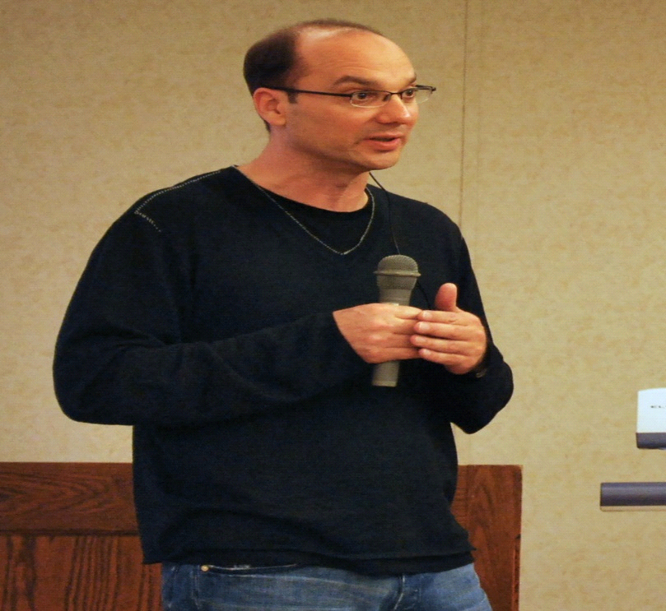

**VERSION**

Android 12 and 19th version of Android,

**VERSION DETAILS**

|  |  |
| --- | --- |
| A version of the [Android](https://en.wikipedia.org/wiki/Android_(operating_system)) operating system | |
|  | |
|  | |
| [**Developer**](https://en.wikipedia.org/wiki/Programmer) | [Google](https://en.wikipedia.org/wiki/Google) |
| **OS family** | [Android](https://en.wikipedia.org/wiki/Android_(operating_system)) |
| [**General**](https://en.wikipedia.org/wiki/Software_release_life_cycle) [**availability**](https://en.wikipedia.org/wiki/Software_release_life_cycle) | October 4, 2021; 2 months ago |
| [**Latest release**](https://en.wikipedia.org/wiki/Software_release_life_cycle) | 12.0.0_r21 (SQ1D.211205.016.A5) / December 15, 2021; 18 days ago |
| [**Kernel**](https://en.wikipedia.org/wiki/Kernel_(operating_system))**type** | [Monolithic Kernel](https://en.wikipedia.org/wiki/Monolithic_Kernel) ([Linux Kernel](https://en.wikipedia.org/wiki/Linux_Kernel)) |
| **Preceded by** | [Android 11](https://en.wikipedia.org/wiki/Android_11) |
|  |  |

FOR MORE DETAILS OF VERSIONS OF ANDROID

[**https://en.wikipedia.org/wiki/Android_version_history**](https://en.wikipedia.org/wiki/Android_version_history)

**ADVANTAGES OF ANDROID:**

• Android is an open-source platform allowing UI customization supports cloud storage enabling sync of devices with G-account supports running multiple apps simultaneously expandable memory & runs on affordable large devices

• Continual improvement & removal of old feature

**2.Web application – Windows is the OS**

**Why windows?**

Allows network-based installation of Windows operating systems, which reduces the complexity and cost when compared to manual installations. ... Allows you to add driver packages to the server and configure them to be deployed to client computers along with the install image.

Windows is easily the most popular OS in terms of market share, with an [estimted 87.89%](https://venturebeat.com/2019/09/01/net-applications-windows-10-windows-7-market-share/)  of PCs running some form of the operating system. Windows devices also tend to be cheaper and more configurable than Apple devices.

Microsoft has been embracing open-source technologies, and allow you to install things like a Bash terminal with [Windows Subsystem for Linux](https://docs.microsoft.com/en-us/windows/wsl/install-win10). These advances should further close the gap between the Windows and Unix based OSs like MacOS and Linux.

**Who developed windows:**

Microsoft Windows, also called Windows and Windows OS, computer operating system (OS) developed by Microsoft Corporation to run personal computers (PCs). Featuring the first graphical user interface (GUI) for IBM-compatible PCs, the Windows OS soon dominated the PC market.

[**Developer**](https://www.google.com/search?rlz=1C1CHBF_enIN975IN975&q=android+developer&stick=H4sIAAAAAAAAAOPgE-LSz9U3MCqvKEkv15LPTrbST87PLSgtSS3SL85PKylPLEq1SkktS83JL0gtWsQqmJiXUpSfmaIAFwMA3gjYy0MAAAA&sa=X&ved=2ahUKEwj-h8zJuZP1AhX-xzgGHWJEBxwQ6BMoAHoECBQQAg) **:** William Henry Gates



**Number of users in the world**

Windows more generally (1.5 billion active users, a number that hasn't moved, magically, in years), and that Google touts for Android (over 1.4 billion).

**Version:**

Windows 11, version 21H2.

**Version details**

|  |  |
| --- | --- |
| **Windows 11** | |
|  | |
|  | |
|  | |
| [**Developer**](https://en.wikipedia.org/wiki/Programmer) | [Microsoft](https://en.wikipedia.org/wiki/Microsoft) |
| [**Written in**](https://en.wikipedia.org/wiki/Programming_language) | * [C](https://en.wikipedia.org/wiki/C_(programming_language)), [C++](https://en.wikipedia.org/wiki/C%2B%2B), [C#](https://en.wikipedia.org/wiki/C_Sharp_(programming_language)), [assembly language](https://en.wikipedia.org/wiki/Assembly_language) |
| **OS family** | [Microsoft Windows](https://en.wikipedia.org/wiki/Microsoft_Windows) |
| **Source model** | * [Closed-source](https://en.wikipedia.org/wiki/Proprietary_software) * [Source-available](https://en.wikipedia.org/wiki/Source-available_software) (through [Shared Source Initiative](https://en.wikipedia.org/wiki/Shared_Source_Initiative)) * Some components [open source HYPERLINK "https://en.wikipedia.org/wiki/Windows_11"[2] HYPERLINK "https://en.wikipedia.org/wiki/Windows_11"[3] HYPERLINK "https://en.wikipedia.org/wiki/Windows_11"[4] HYPERLINK "https://en.wikipedia.org/wiki/Windows_11"[5]](https://en.wikipedia.org/wiki/Open-source_software) |
|  |  |
| [**General**](https://en.wikipedia.org/wiki/Software_release_life_cycle) [**availability**](https://en.wikipedia.org/wiki/Software_release_life_cycle) | October 5, 2021; 2 months ago[6] |
| [**Latest release**](https://en.wikipedia.org/wiki/Software_release_life_cycle) | 21H2 (10.0.22000.376) (December 14, 2021; 19 days ago[[7]](https://en.wikipedia.org/wiki/Windows_11)) [[±]](https://en.wikipedia.org/w/index.php?title=Template:Latest_stable_software_release/Windows_11&action=edit) |
| [**Latest preview**](https://en.wikipedia.org/wiki/Software_release_life_cycle) | 10.0.22523.1000 |
| **Marketing target** | [Personal computing](https://en.wikipedia.org/wiki/Personal_computing), [tablets](https://en.wikipedia.org/wiki/Tablet_computer) |
|  |  |
|  | |
| **Update method** | * [Windows Update](https://en.wikipedia.org/wiki/Windows_Update) * [Microsoft Store](https://en.wikipedia.org/wiki/Microsoft_Store_(digital)) * [Windows Server Update Services](https://en.wikipedia.org/wiki/Windows_Server_Update_Services) (WSUS) |

FOR MORE DETAILS OF VERSIONS OF ANDROID

[**https://en.wikipedia.org/wiki/Microsoft_Windows_version_history**](https://en.wikipedia.org/wiki/Microsoft_Windows_version_history)

**ADVANTAGES OF WINDOWS AS OS:**

* Ease of use. Users familiar with earlier versions of Windows will probably also find the more modern ones easy to work with. ...
* Protected and supervisor mode. Allows disk access and file systems Device drivers Networking Security. Program Execution. Memory management Virtual Memory Multitasking
* Available software, Backwards compatibility, Games….
* AI-Powered Widgets. That's right, Widgets are back! ...
* Compatibility with MS driven websites.

**Suitable operating system(s) for the clients to use the Application**

1.Mobile – Android, IOS

2.Laptops/Desktops – Windows/Linux/Mac

**DATABASE DESIGN AND QUERIES FOR THE APPLICATION**

**Introduction:**

A database management system (or DBMS) is essentially nothing more than a computerized data-keeping system. Users of the system are given facilities to perform several kinds of operations on such a system for either manipulation of the data in the database or the management of the database structure itself.

**Types of databases:**

* Relational database - A relational database is a collection of data items with pre-defined relationships between them.
* Object oriented database - An object-oriented database (OOD) is a database system that can work with complex data objects
* Hierarchical database - A hierarchical database is a data model in which data is stored in the form of records and organized into a tree-like structure.
* Network database - A network database is a type of database model wherein multiple member records or files can be linked to multiple owner files and vice versa

**DATABASE SCHEMA DESIGN: ER MODEL**

**Entities:** Management, Employee, Login, News, Advertisement, Posts

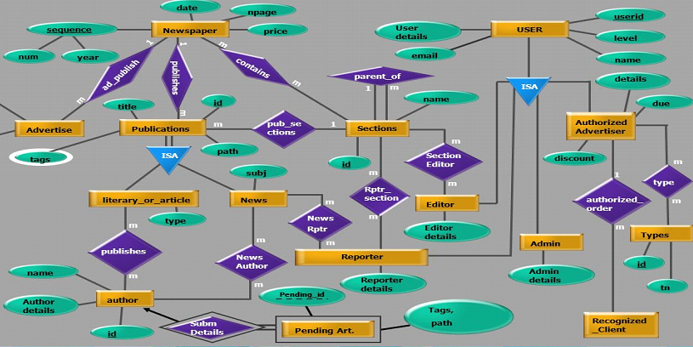

**Schema diagram:**

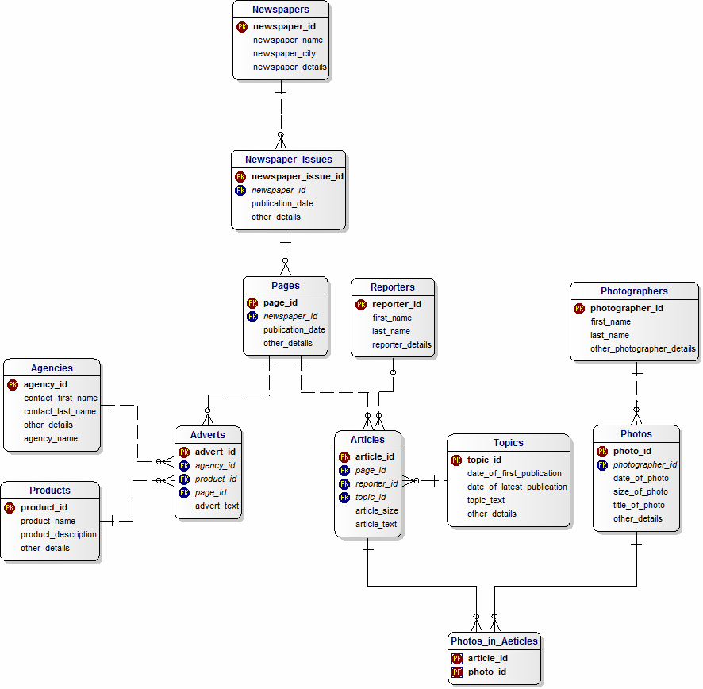

**Tables and keys:**

**TABLE NAME:**

|  |  |
| --- | --- |
| NEWSPAPER | PAGES |
| NEWSPAPER ISSUES | AGENCIES |
| ADVERTS | PRODUCTS |
| REPORTERS | TOPICS |
| ARTICLES | PHOTOS IN ARTICLES |
| PHOTOS | PHOTOGRAPHERS |

**PRIMARY KEY:**

|  |  |
| --- | --- |
| NEWSPAPER ISSUES ID | PAGES ID |
| AGENCY ID | ADVERT ID |
| PRODUCT ID | REPORTER ID |
| ARTICLE ID | PHOTO ID |
| TOPIC ID | PHOTOGRAPHER ID |

**FOREIGN KEY:**

|  |
| --- |
| NEWSPAPER ID |
| PAGES ID |
| AGENCY ID |
| PRODUCT ID |
| REPORTER ID |
| PHOTOGRAPHER ID |
| TOPIC ID |

**DDL AND DML QUERIES:**

DDL Queries:

* CREATE – Create an object like create database, index, etc.
* DROP – This SQL DDL command helps to delete objects. For example, delete tables, delete a database, etc.
* ALTER– Used to alter the existing database or its object structures.
* TRUNCATE– This command removes records from tables

DML Queries:

* SELECT– This SQL DML command select records or data from a table.
* INSERT– Insert data into a database table.
* UPDATE – This SQL DML command will update existing records within a table.
* DELETE– Delete unwanted records from a table.

**1.CREATE TABLE:**





**2.ALTER:**

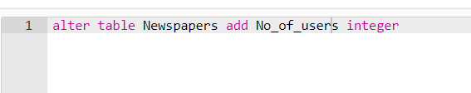

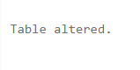

**3.DROP:**

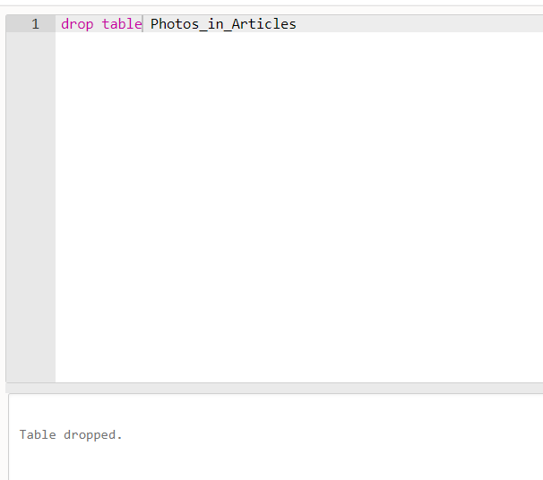

**4.TRUNCATE:**

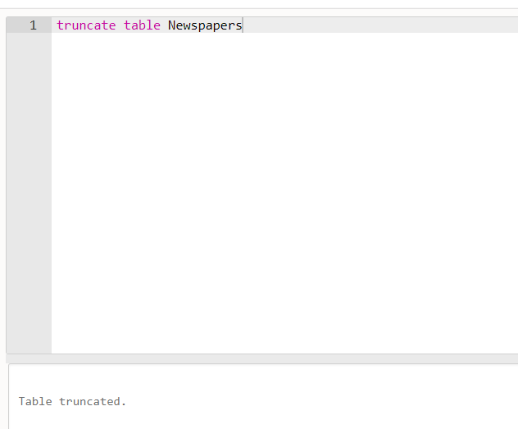

**5.SELECT:**

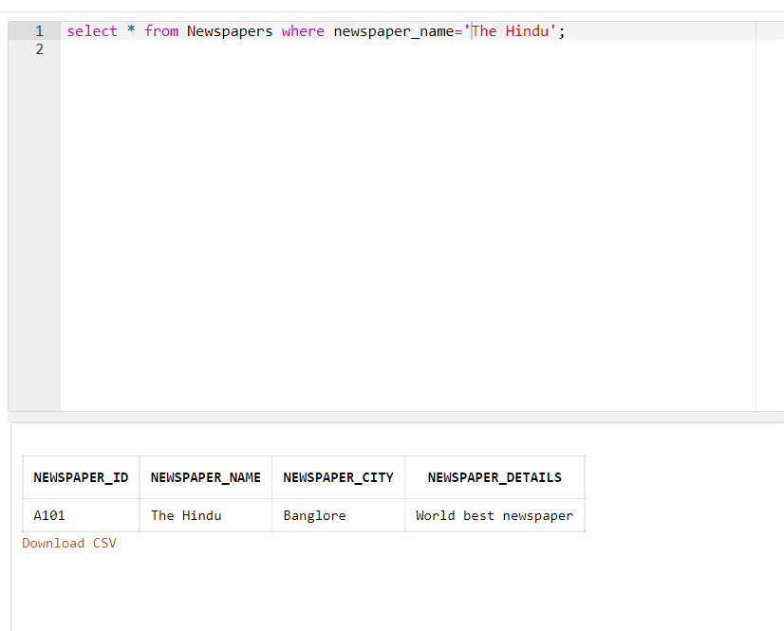

**6.INSERT:**

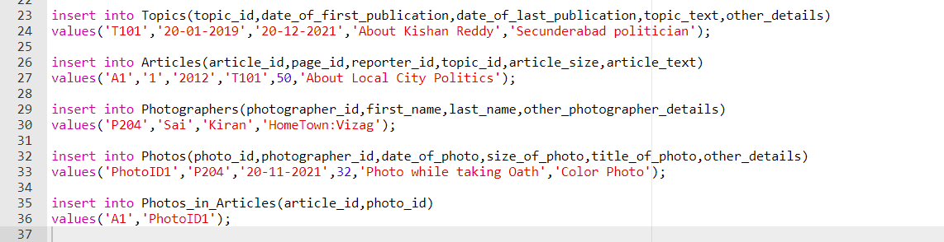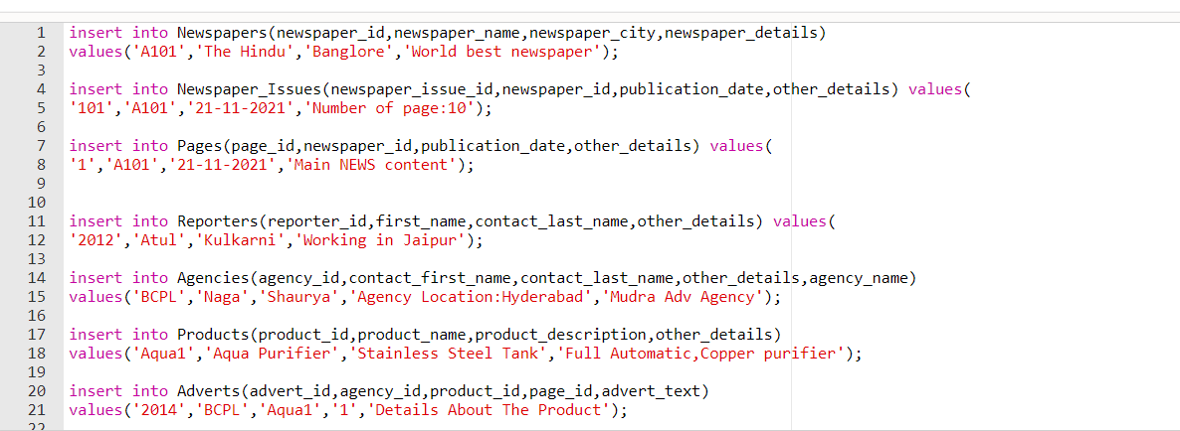

**7.UPDATE:** 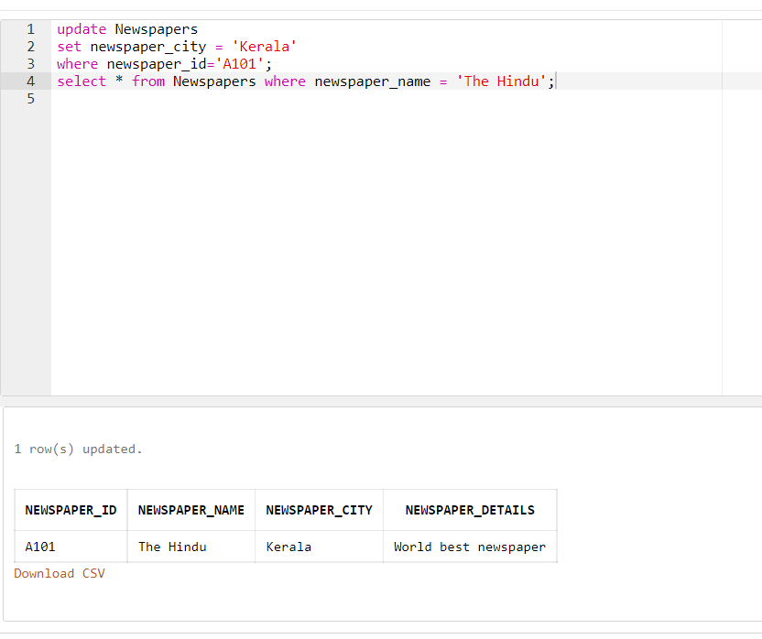

**8.DELETE:**

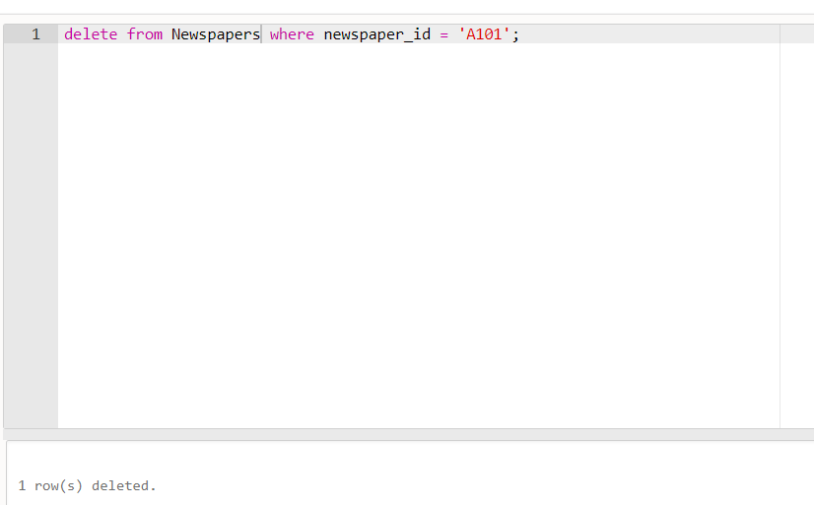

**Constraints available in our SQL are:**

1. PRIMARY KEY
2. FOREIGN KEY
3. NOT NULL

THESE 3 CONSTRAINTS MENTIONED IN CREATE TABLE PART.

**BUSINESS RULES:**

* Each user must register to apply for publishing his/her article.
* Political news, employment news, education updates, question papers, student problems, Human rights, children's programs, diseases, historic details, celebrities, sports, industrial issues, Vaccination details etc…
* Collect comments, collaborate on responses and track progress in real time all in one place from desktop, mobile or web. No more sorting through endless email chains. No delays. No interruptions.
* Requires annual commitment. For Windows and Mac.

Pro annual, paid monthly

Pro annual, paid monthly,5-license pack – 7.5% off

Pro annual, prepaid

Pro annual, prepaid, 5-license pack – 7.5% off

Standard manual, paid monthly

Standard manual, prepaid

**\* All languages in India and English\***

**NETWORKING MODEL FOR THE APPLICATION**

**WHAT IS A TOPOLOGY:**

A network topology describes the way that it’s arranged, including all of its nodes or intersecting points, and the lines connecting the various network elements. Topologies are typically illustrated in schematic or diagrammatic form, with symbols or icons representing the nodes, and lines depicting the connections or runs of cable.

There are various type of topologies. Hey are:

* Star topology
* Mesh topology
* Bus topology
* Tree topology
* Ring topology

In online newspaper we have chosen **Mesh Topology.**

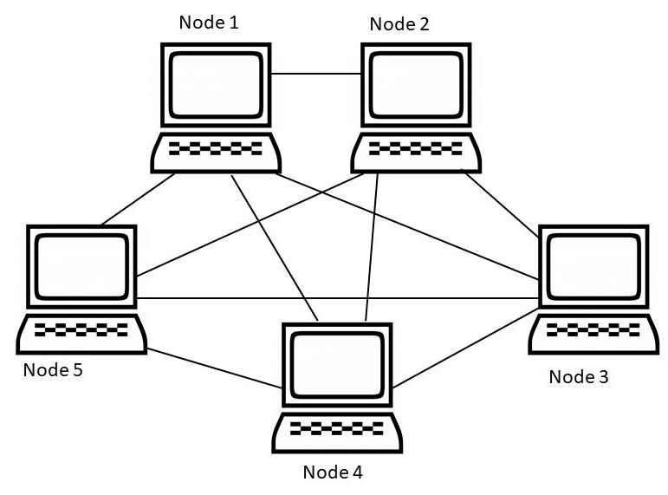

**MESH TOPOLOGY:**

Communications made on a mesh network topology may take any of several possible paths from their source to their destination. Mesh network topologies are typical of the internet, and certain wide area networks (WANs). Data may be transmitted via a routing logic, which is determined by set criteria such as “path of shortest distance” or “avoid broken links”. Alternatively, a technique known as flooding may be used, where the same information stream is transmitted to all network nodes, without prejudice.

**ADVANTAGES:**

* Messages can be received more quickly if the route to the intended recipient is short.
* New nodes can be added without interruption or interfering with other nodes.

**DISADVANTAGES:**

* Full mesh networks can be impractical to set up because of the high number of connections needed.
* Many connections require a lot of maintenance.

**METHOD OF PROCESS:**

The method of the process used is the client-server model. The client-server model is a distributed communication framework of network processes among service requestors, clients, and service providers. Client server architecture is arranged in a way that clients are often situated at workstations or on personal computers, while servers are located elsewhere on the network.

The client-server model is centralized networking.

**Benefits of Client-Server Computing**

* A single server hosting all the required data in a single place facilitates easy protection of data and management of user authorization and authentication.
* Resources such as network segments, servers, and computers can be added to a client-server network without any significant interruptions.
* Data can be accessed efficiently without requiring clients and the server to be in close proximity.
* All nodes in the client-server system are independent, requesting data only from the server, which facilitates easy upgrades, replacements, and relocation of the nodes.

Data that is transferred through client-server protocols are platform-agnostic.

**NETWORK PROTOCOLS:**

A protocol is a formal description of message formats and the rules that two or more machines must follow to exchange both messages.

The main protocols built around the client-server model are:

* Hypertext Transfer Protocol (HTTP)
* Domain Name System (DNS)
* Simple Mail Transfer Protocol (SMTP)
* TELNET (Terminal network)
* Network News Transfer Protocol (NNTP)

In online Newpaper we used NNTP. is an application protocol used for transporting UseNet news articles (*Netnews*) between news servers, and for reading/posting articles by the end user client applications.

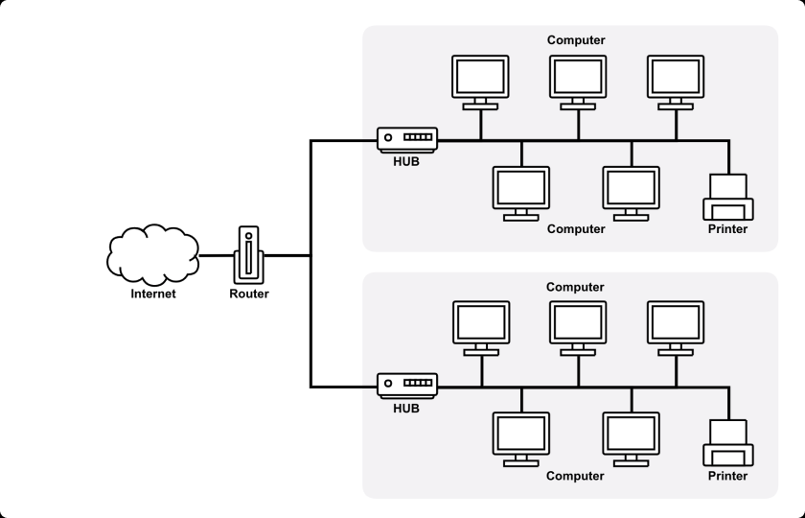

**SUMMARY**

* The platforms selected are mobile and web application.
* We have taken android into consideration in case of mobile application and windows in the case of web application.
* We use java language to make a mobile application.
* The price estimate to build an app will be $15K approx. and is precisely same for a website.
* We came across 8 SQL queries in the DBMS part.
* We designed an ER diagram to have a clear picture of what actually should happen while building an app or a website.
* We’ve used mesh topology to network various pcs or mobiles.
* We also came across various network protocols in networking part.

**WAYS TO MARKETIZE**

* Have a user-friendly interface so that user recommends it to other clients.
* Make use of social media.
* Provide search options.
* Make your website interactive.
* Use an A.I bot that guides the user throughout the website or app.

**REFERENCES**

* www.geekforgeeks.com
* www.ignoustudentcare.blogspot.com
* www.freeprojectz.com
* www.erdplus.com
* www.projectworlds.in
* www.w3school.com

THANK YOU!!!